**Experiment No. 4**

**Title: Demonstrate the process of meteor app development and display features of meteor.**

**Batch:B1 Roll No.:1514033 Experiment No.:4**

### Aim: Demonstrate the process of meteor app development and display features of meteor.

### --------------------------------------------------------------------------------------------

**Resources needed:** Meteor

### Theory:

Meteor is a full-stack JavaScript platform for developing modern web and mobile applications. Meteor includes a key set of technologies for building connected-client reactive applications, a build tool, and a curated set of packages from the Node.js and general JavaScript community.

* Meteor allows you to develop in one language, JavaScript, in all environments: application server, web browser, and mobile device.
* Meteor uses data on the wire, meaning the server sends data, not HTML, and the client renders it.
* Meteor embraces the ecosystem, bringing the best parts of the extremely active JavaScript community to you in a careful and considered way.
* Meteor provides full stack reactivity, allowing your UI to seamlessly reflect the true state of the world with minimal development effort.

Step to create a project:

To create the app, open your terminal and type:

>meteor create myapp

Run it locally:

cd myapp  
meteor npm install  
meteor  
# Meteor server running on: http://localhost:3000/

### Results: (Screen shots of application development steps, program code and web browser displaying the specified message.)

1. Meteor Project Location

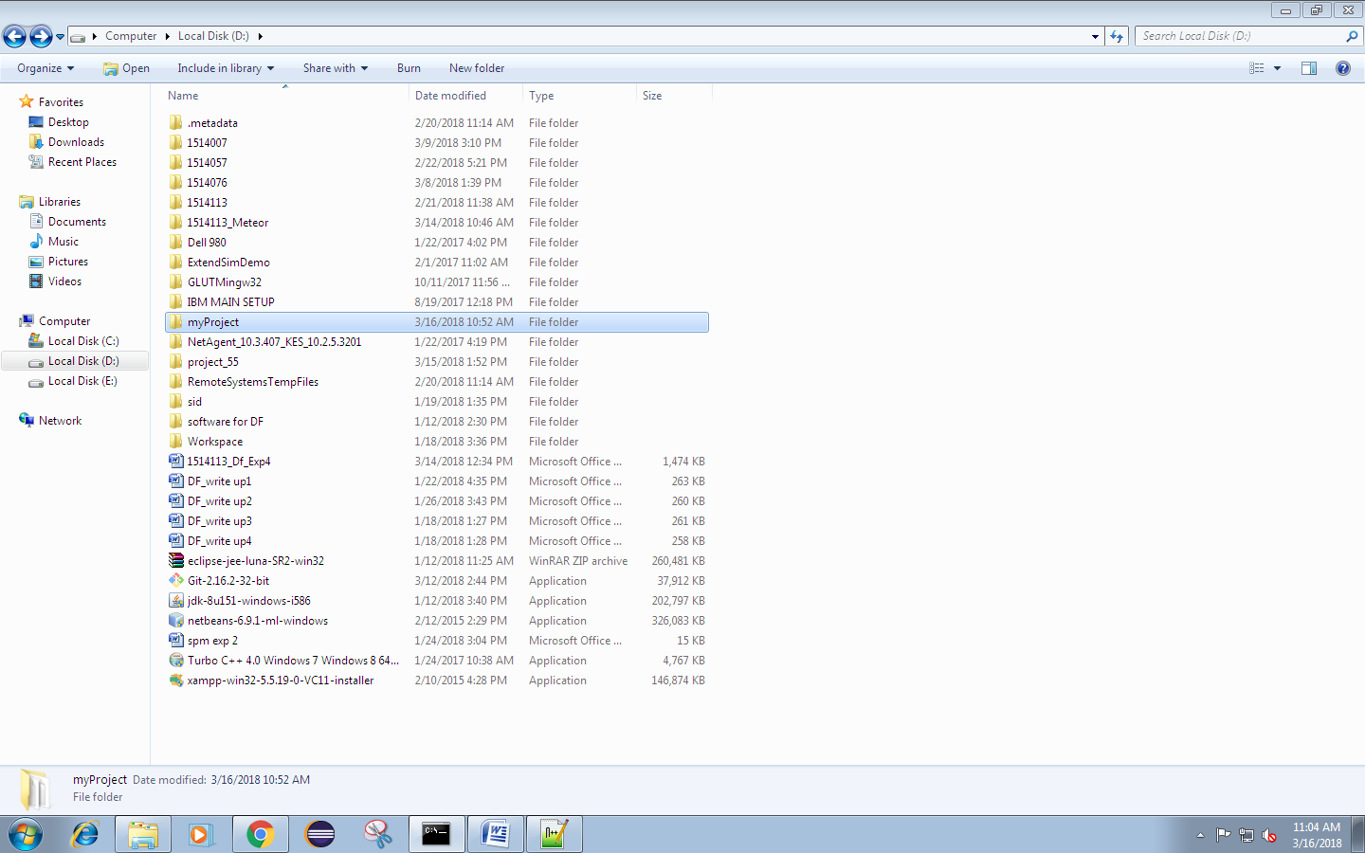

2..meteor , client and server folder

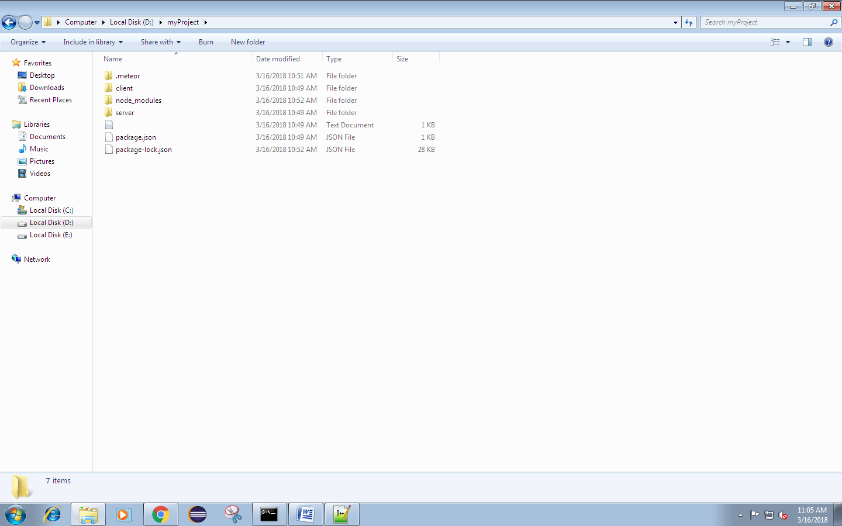

1. HTML , CSS and JS file

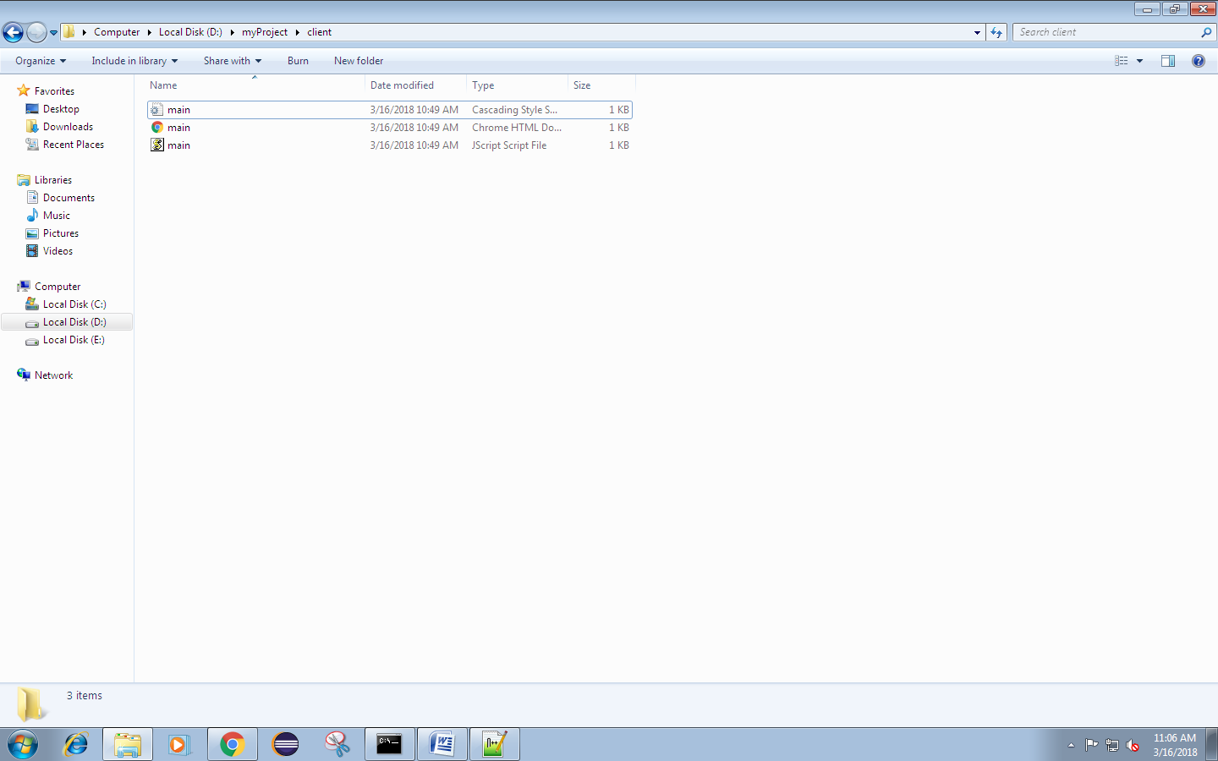

1. Default Meteor Page

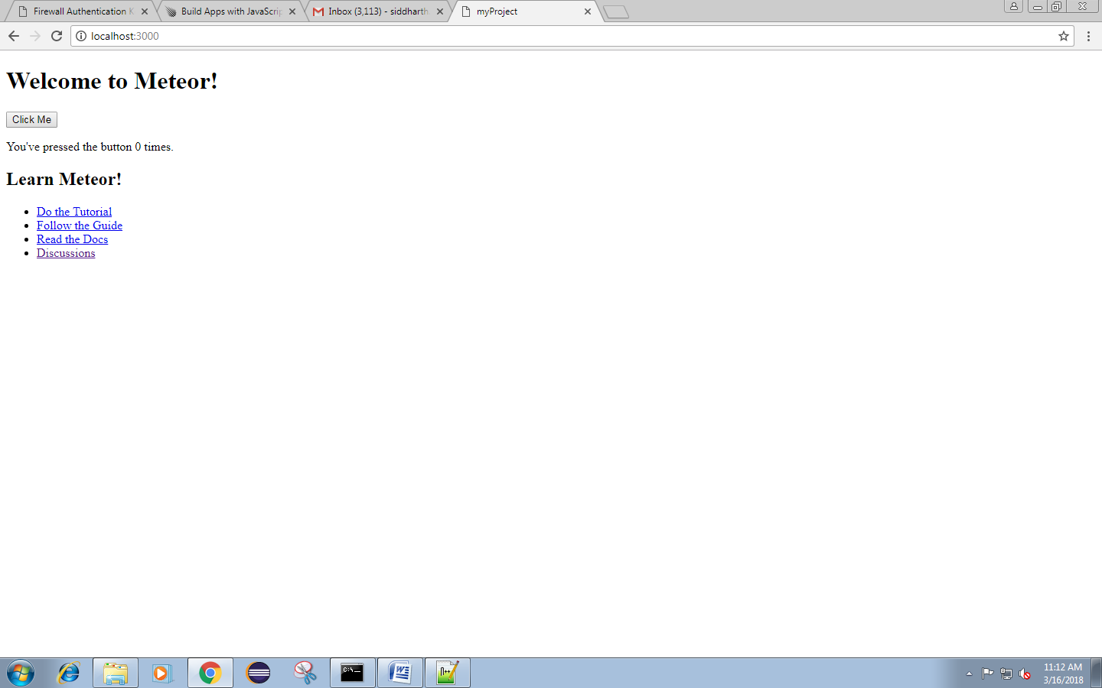

1. Customized webpage with meteor

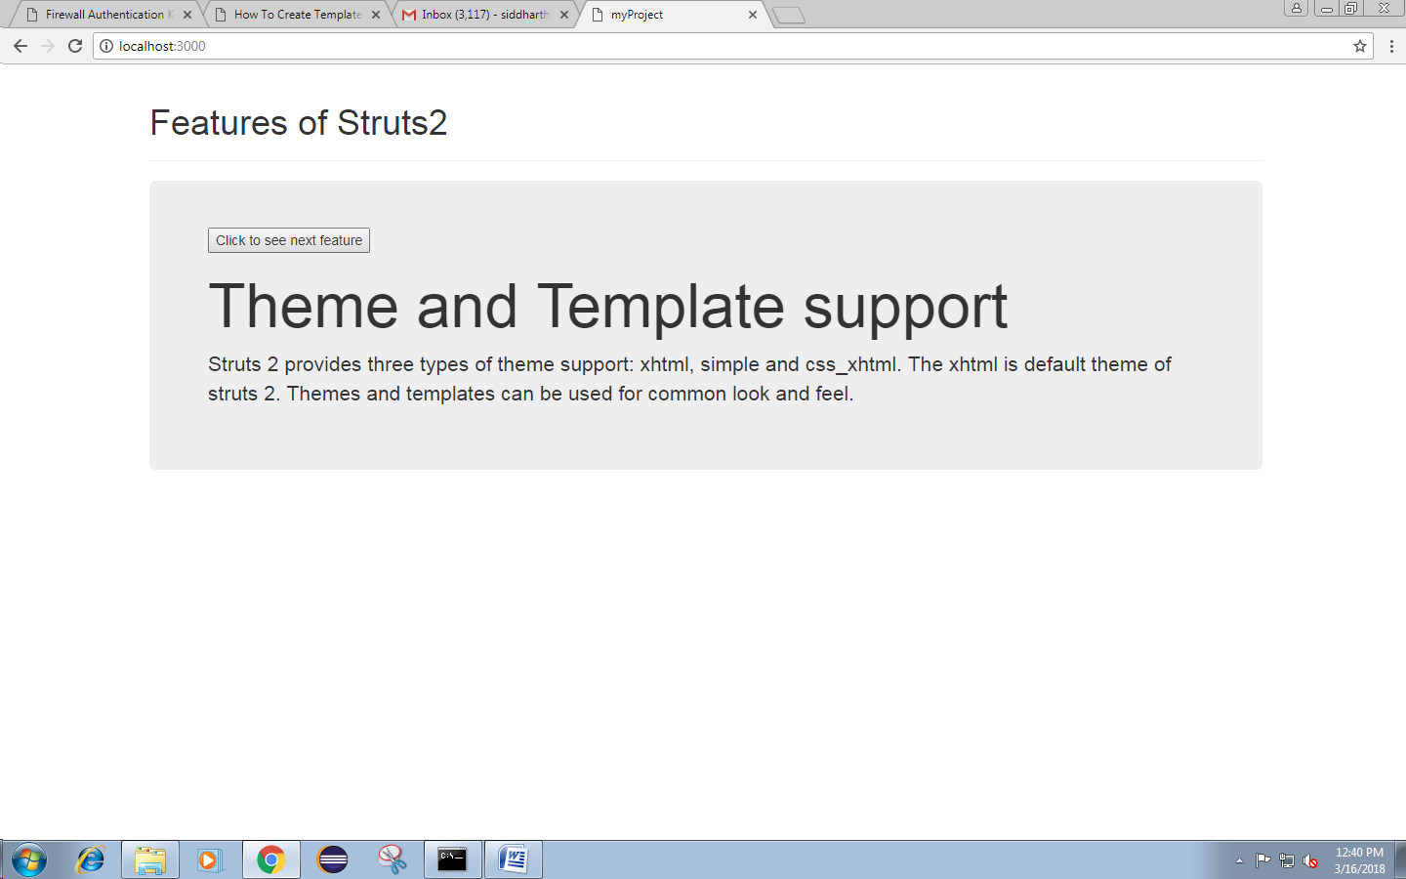This Webpage loads the data dynamically without reloading the webpage on a click of a button. The webpage displays seven features of Struts2 one at a time. When user clicks the button for the eighth time he would see the first feature of Struts2 again and the loop will continue.

**CODE:**

**Main.html**

<head>

<title>myProject</title>

<meta charset="utf-8">

<meta name="viewport" content="width=device-width, initial-scale=1">

<link rel="stylesheet" href="https://maxcdn.bootstrapcdn.com/bootstrap/3.3.7/css/bootstrap.min.css">

<script src="https://ajax.googleapis.com/ajax/libs/jquery/3.3.1/jquery.min.js"></script>

<script src="https://maxcdn.bootstrapcdn.com/bootstrap/3.3.7/js/bootstrap.min.js"></script>

</head>

<body>

<div class="container">

<div class="page-header">

<h1>Features of Struts2</h1>

</div>

<div class="jumbotron">

{{>clickButton}}

</div>

</div>

</body>

<template name="clickButton">

<button>Click to see next feature</button>

<h1>{{heading}}</h1>

<p>{{info}}</p>

</template>

**Main.css**

No changes

**Main.js**

import { Template } from 'meteor/templating';

import { ReactiveVar } from 'meteor/reactive-var';

import './main.html';

let heading,info

Template.clickButton.onCreated(function loadData(){

heading = ['Configurable MVC components','POJO based actions','AJAX support','Integration Support','Various Result Types','Various Tag support','Theme and Template support']

info = ['In struts 2 framework, we provide all the components (view components and action) information in struts.xml file. If we need to change any information, we can simply change it in the xml file.','In struts 2, action class is POJO (Plain Old Java Object) i.e. a simple java class. Here, you are not forced to implement any interface or inherit any class.','Struts 2 provides support to ajax technology. It is used to make asynchronous request i.e. it doesn\'t block the user. It sends only required field data to the server side not all. So it makes the performance fast.','We can simply integrate the struts 2 application with hibernate, spring, tiles etc. frameworks.','We can use JSP, freemarker, velocity etc. technologies as the result in struts 2.','Struts 2 provides various types of tags such as UI tags, Data tags, control tags etc to ease the development of struts 2 application.','Struts 2 provides three types of theme support: xhtml, simple and css_xhtml. The xhtml is default theme of struts 2. Themes and templates can be used for common look and feel.']

this.counter = new ReactiveVar(0)

this.currentHeading = new ReactiveVar(null)

this.currentInfo = new ReactiveVar(null)

});

Template.clickButton.helpers({

heading(){

return Template.instance().currentHeading.get();

},

info(){

return Template.instance().currentInfo.get();

},

});

Template.clickButton.events({

  'click button'(event, instance) {

    // increment the counter when button is clicked

    instance.counter.set(instance.counter.get() + 1);

if(Template.instance().counter.get()>7)

instance.counter.set(1);

let count = Template.instance().counter.get()

instance.currentHeading.set(heading[count-1])

instance.currentInfo.set(info[count-1])

currentInfo = info[count-1]

console.log("working?")

console.log(count)

console.log(instance.currentHeading.get())

console.log(instance.currentInfo.get())

  },

});

/*Template.hello.onCreated(function helloOnCreated() {

  // counter starts at 0

  this.counter = new ReactiveVar(0);

});

Template.hello.helpers({

  counter() {

    return Template.instance().counter.get();

  },

});

Template.hello.events({

  'click button'(event, instance) {

    // increment the counter when button is clicked

    instance.counter.set(instance.counter.get() + 1);

  },

});

*/

_________________________________________________________________________________

**Questions:**

1. Explain advantages of meteor.

- Only one language,  JS both front-end and back-end  
- Meteor can be used for reactive programming out of the box  
- Lot of magic, you won't spend too much time over configuration,  especially if you come from a django background  
- Meteor official support for react,  Angular   
- Meteor is quite easy to learn,  and you will be able to build prototypes right away without too much effort,  due to it's magic (tracker ect..)

### Outcomes:Demonstrate the process of meteor app development and display features of meteor







**Conclusion: (Conclusion to be based on the objectives and outcomesachieved)**

**A simple meteor app was made by using html , css and javascript using template feature provided by meteor**









**Grade: AA / AB / BB / BC / CC / CD/DD**

**Signature of faculty in-charge with date**



**References:**

1. By Isaac Strack; “Getting Started with Meteor.js JavaScript Framework”, 2nd Edition

;Packt Publishing, June 2015